Resume of Kamrul Hossain
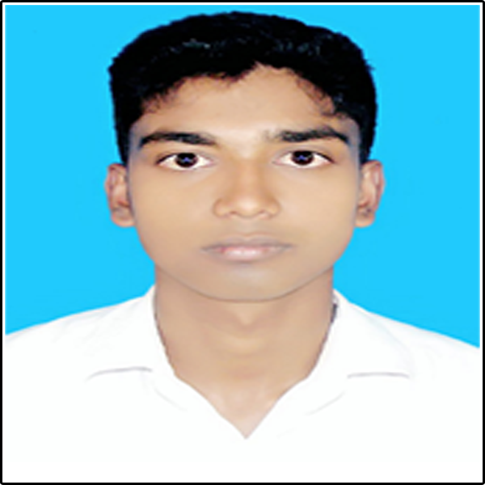
Mailing Address:
C/O. Golam Maola
House, Abul Bashar Notun Bari,
Vill- Charfakira,
P.O. Charfakira,
P.S: Companyganj, Dist. Noakhali.
Cell: +88 01865613145.

Career Objective: Intend to work in a challenging competitive environment where strong sense of responsibility and commitment is required, where dignity of work provide, job satisfaction and place of work provide, potential avenues for the pot level in the hierarchy of the organization.

Educational Qualifications:

- DIPLOMA IN ENGINEERING
Year : 2021
Group : Computer
GPA : Running out of 4.00
Institution : Institute of Computer Science and Technology
Board : BTEB(Dhaka)

- S.S.C. (Secondary School Certificate)
Year : 2017
Group : Science
GPA : 3.27 out of 5.00
Institution : Charfakira High School
Board : Comilla Board

Language Proficiency :

- Bangla : Speaking And Writing-Excellent
- English : Speaking and Writing-Good

Computer Skill :

- Microsoft office - MS Word, MS Excel, MS Power Point, MS Access.
- Programming {
- HTML 80%
- CSS60%
- C++ 10%
- C 10%
- Java 20%
- PHP 20%
- Laravel 10%
- And Other Many Languages
- Internet access (Downloading important data and web report) and e-mail access.

Personal Profile :

Name : Kamrul Hossain
Father's Name : Golam Maola
Mother's Name : Munsura Khatun
Nationality : Bangladeshi by birth
Religion : Islam
Sex : Male
Marital Status : Single
Date of birth : 01th January, 2000
Blood Group : B+
Nid : 20007512111000339

Declaration:

I hereby declare that all information stated in the curriculum vitae is true and complete to the best of my knowledge



Date: 01/02/2020 Kamrul Hossain

